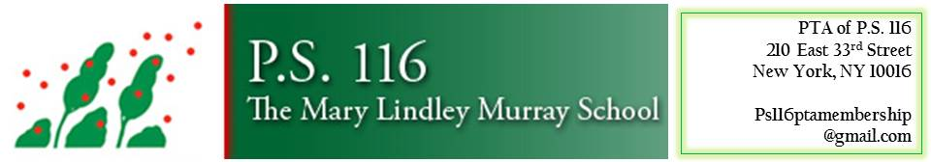

Minutes from 10.24.18 General P.T.A. Meeting

Words from Mr. Shevell:(Ms. Hsu off site)
Art Night was a success this past Friday night! Big thank you to all who organized and volunteered.
Boo Bash is this Saturday 10/27. Great safe Halloween event at school.
Over 2000 new books ha e arrived for the library. Every book needs a sticker label put inside with “Property of PS 116” and then they need to be sorted and shelved. We need volunteers for an hour or two. Please email ps116pta.com if you are interested.
Regarding Safety: first lockdown drill will be next week for all classrooms. Also Safety Protocol Workshop for families will be this Friday, 10/26 in the cafeteria after drop off at 8:30 for about an hour. This contains very important information that cannot be sent home in fliers. Parents are urged to attend.
Curriculum chess, Studio In A School and Dancing Classrooms are all underway.
Words from PTA Presidents:
Good turn out for today’s meeting. Please continue to attend and bring a friend. November’s meeting will have our council members in attendance and at December’s meeting police officers from our local precinct will be there.
October has been a busy month at school. We had our first families as buddies this past Friday.
Big thank you to all our new class parents.
Running Club just started this past Friday and will be every Friday morning before school from 7:20-8:00am Permission slips were sent home. Thank you to all the new parents who stepped up to volunteer and run Running Club.
We have a new PTA website
Ps116pta.com
Please let us know if you have something to share
We had a successful Parent Mixer.
Thank you to the Hospitality Team.
Thanks to the Community Building Committee for Art Night as well as all the parents who volunteered and donated art supplies. We have a lot of extra art supplies for future use.
Education Committee updates:
Photo Day Retake Day will be 11/5. Please return the old photos and take new ones.
Read-a-thon will be 11/1 Thru 11/16. Fliers will be going home. We raised almost $10,000 last year. It is a lump sum donation and not based on minutes read. Kids can get prizes for minutes read and classes who read the most in each grade will receive a pizza party.
Vision screening for 2nd and 4th graders will be starting soon.
Community Outreach Meetings are a good resource for us to voice our opinions and problems, in addition to our safety concerns.
The police are there to listen as well as our council members. Call 311 and call your council members.
Scholastic is running our book fair this year. Book Fair will be in the gym from 11/27-11/29
11/26 is set up day and on 11/27 there will be a free launch party in the evening from
6-8pm. Author will be there. We will need volunteers and there will be a training day to learn the system. We will also have a book drive where you can donate lightly used books so that students who do not bring in book fair $ can still pick a book to take home. Books are great for holiday gifts and teacher wishlists will be posted so families can buy books or vouchers to donate books to their classrooms.
Internal Fundraising update:
Please donate if you can. Any amount helps.
Your donations supplement school events and programs such as Studio In A School and the Teaching Assistant fund. Likewise, school supplies such as our new snow blower were purchased with donation money. If you work for a corporation you can apply for corporate matching. It is tax-deductible.
BooBash is this Saturday 10/27. This is one of our biggest money makers of the year and one event that the kids can’t stop talking about!
Boo Bash volunteers are still needed especially 2:30-4:00pm time slot for Pre-K and 1st graders. We need candy donations and baked goods

